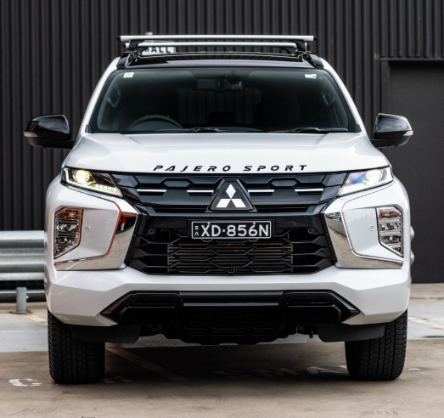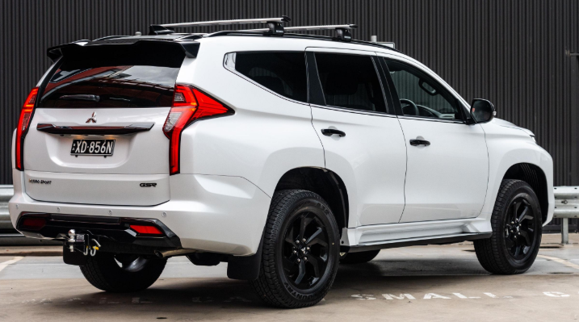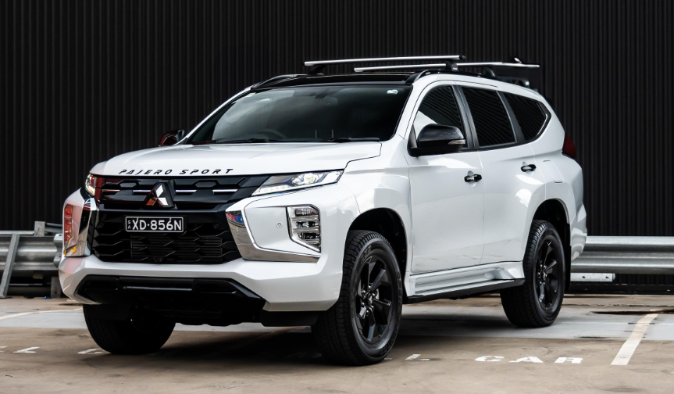

**Main Specifications** for the **2025 Mitsubishi Pajero**

**🚗 Powertrain & Performance**

* **Engine Options**:
  + **3.0 L V6 petrol**: ~177 hp @ 5,250 rpm, 261 Nm @ 4,000 rpm; 5-speed automatic
  + **3.2 L V6 diesel**: ~189 hp, 441 Nm torque; 5-speed automatic
* **Top Speed**: ~180 km/h
* **Fuel Economy**: ~6–7 km/L overall (~8 km/L highway)
* **Fuel Tank**: 69–88 L

**📏 Dimensions & Capacities**

* **Length × Width × Height**: 4,385 × 1,875 × 1,850 mm
* **Wheelbase**: 2,545 mm
* **Ground Clearance**: 225 mm
* **Kerb Weight**: 1,960–2,240 kg
* **Seating**: 5–7 seats
* **Boot Space**: ~999 L

**🛠️ Chassis, Suspension & Brakes**

* **4WD Type**: Super Select 4WD II with Low Range and center-differential lock
* **Suspension**: Double-wishbone front; double-wishbone or multi-link rear
* **Brakes**: Ventilated discs (front & rear)

**🛋️ Steering, Wheels & Tires**

* **Steering**: Hydraulic rack & pinion; turning radius ~5.3 m
* **Wheels/Tires**: 17″ alloys with 265/65 R17 tires

**⛽ Fuel & Load**

* **Towing Capacity**: ~3,500 lb (1,588 kg

**🛡️ Tech & Comfort**

* Basic features: power windows, leather seats, dual-zone climate control (market-dependent)
* Safety: ABS, EBD, airbags (2–7 depending on variant), ASTC, hill-start; 10‑yr warranty offered in some regions

**🗣️ Real‑World Feedback**

* Reddit users call it a **“poor man’s Land Cruiser”**, praising its **rugged reliability** but noting the cabin is **noisy** and fuel economy is **modest** (5–7 km/L in city driving)
* Spare parts remain **accessible worldwide**, supporting ownership even after discontinuation

**✅ Summary**

The Mitsubishi Pajero is a durable, full-size 4WD SUV with:

* 3.0 L petrol or 3.2 L diesel V6 engines,
* robust off-road kit (Super Select 4WD II, good ground clearance),
* seating for up to 7 and nearly 1,000 L cargo space,
* strong reliability track record, albeit with poor fuel efficiency and basic interior refinement.